Exploratory Analysis of Mysis Length-Weight

- Removed all individuals with wts that were missing
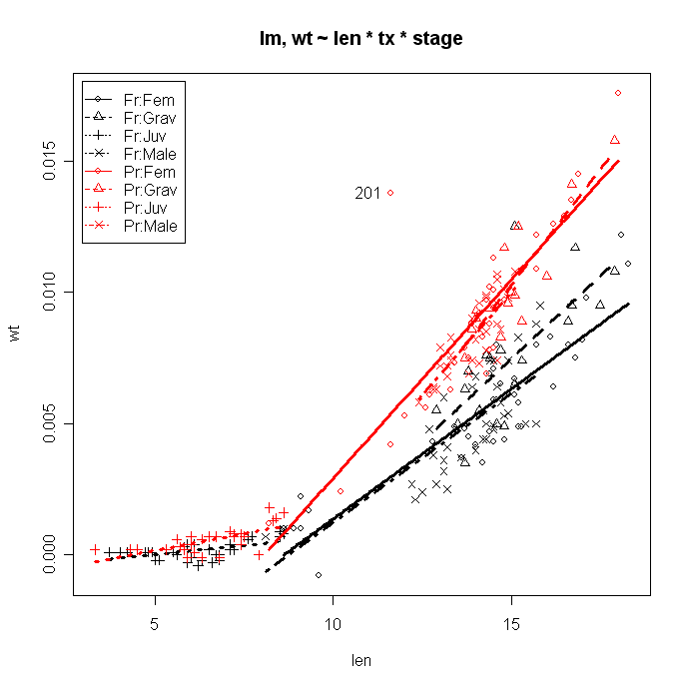
Potential outlier in row 201(original row 208) – info below
ID stage tx len wt
208 201 Fem Pr 11.6 0.0138
Decided to remove it.

- Removed individual 201 – wt too large for length
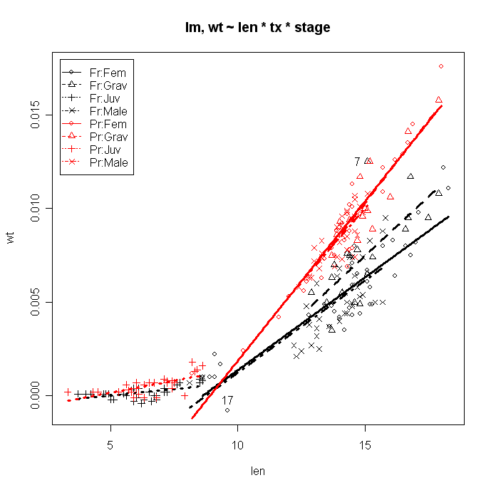
Potential outliers in row 7 and 17 (see above) – info below
ID stage tx len wt
7 7 Grav Fr 15.1 0.0125
19 19 Fem Fr 9.6 -0.0008

Hypothesis tests indicate a non-constant variance and non-normality
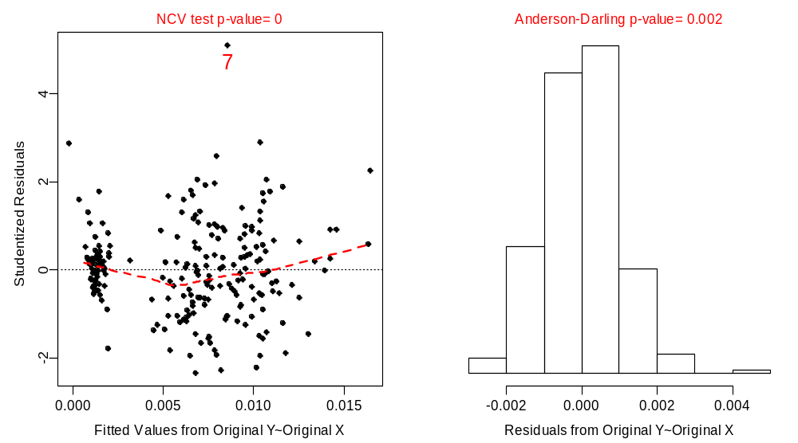

Log-log transformation was not an improvement (actually was worse) but the individual in row 17 was an even stronger outlier.

Almost anything with the sqrt(wt) was an improvement – sqrt-sqrt was good except that the individual in row 17 was a strong outlier.

- Separated juveniles and non-juveniles.
  - Non-juvenile analysis
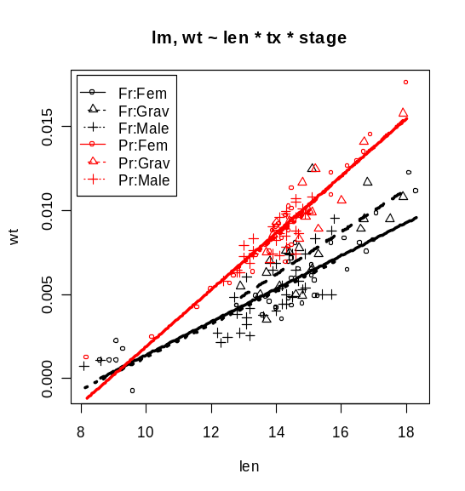
Individuals in rows 7 and 17 are still potential outliers. Non-constant variance test passes though the residual plot shows a slight heteroscedasticity, a large outlier in row 7, and a problematic group of individuals at low fitted values (i.e., small Mysis). The normality test also passed.

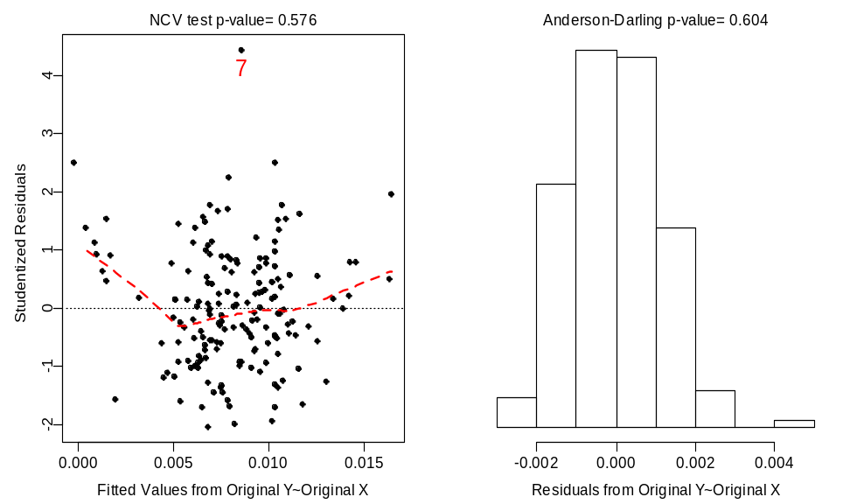

A Type-II SS ANOVA table for the model as it stands ….

Anova Table (Type II tests)

Response: wt
Sum Sq Df F value Pr(>F)
len 0.00075461 1 519.4742 < 2.2e-16 ***
tx 0.00043873 1 302.0252 < 2.2e-16 ***
stage 0.00001287 2 4.4286 0.01344 *
len:tx 0.00004613 1 31.7525 7.78e-08 ***
len:stage 0.00000233 2 0.8008 0.45079
tx:stage 0.00000874 2 3.0084 0.05219 .
len:tx:stage 0.00000060 2 0.2082 0.81230
Residuals 0.00023097 159

An insignificant ln:tx:stage interaction suggests that the slopes do not differ “weirdly” among the treatments. A slightly significant treatment:stage interaction indicates that there is a slight interaction effect in the intercepts (probably due to the fact that the intercept for gravid females appear different from the intercept for males and females in the fresh group but not the preserved group). The insignificant len:stage term indicates that there is no difference in slopes among these three stages. The significant len:tx term indicates that there is a significant difference in slopes among the two treatments.

  - Juvenile analysis
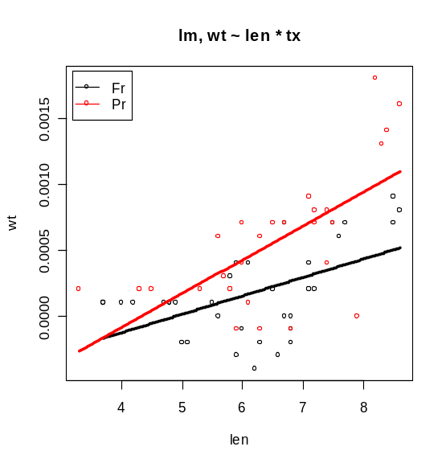

Non-constant variance and normality test both failed on raw scale. I did not find an obvious scale where the assumptions were met. A polynomial regression fit might work.

Ultimately, we need to figure out what to do about the negative weights. Did you combine the individuals that were less than 5 mm, obtain one weight, and then divide by the number of individuals to “assign” a weight to the individuals? Just wondering because none of the individuals under 5 mm had negative numbers which is counterintuitive. If that is the case, then the recommendation should be to do this for individuals under about 7 or 8 mm I would guess.

- Non-juvenile analysis, individuals larger than 11 mm
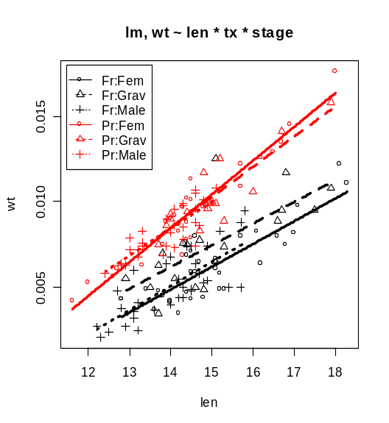
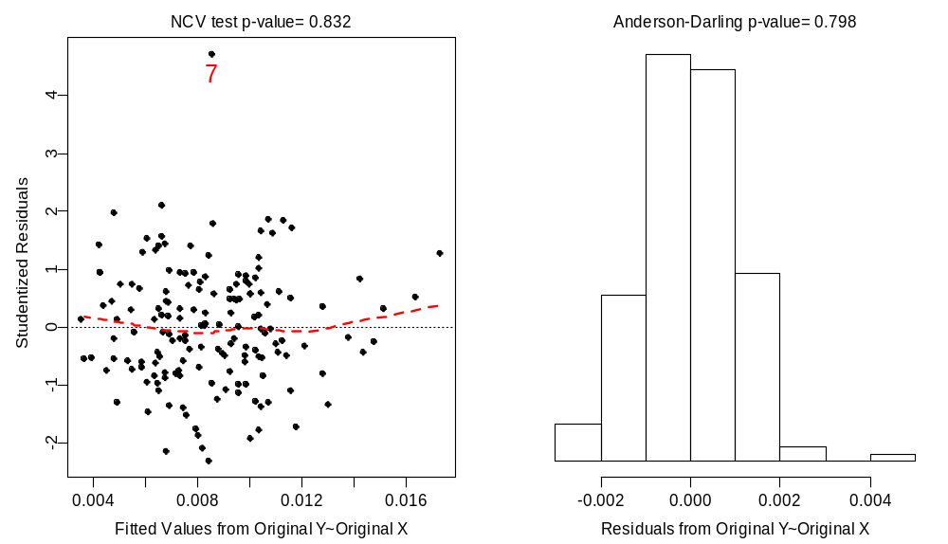

Anova Table (Type II tests)
Response: wt
Sum Sq Df F value Pr(>F)
len 0.00053623 1 408.5915 < 2.2e-16 ***
tx 0.00048416 1 368.9117 < 2.2e-16 ***
stage 0.00001006 2 3.8312 0.023852 *
len:tx 0.00001369 1 10.4292 0.001526 **
len:stage 0.00000080 2 0.3053 0.737393
tx:stage 0.00001029 2 3.9191 0.021939 *
len:tx:stage 0.00000186 2 0.7083 0.494149
Residuals 0.00019555 149

Pretty similar results except that the tx:stage interaction is now significant (instead of only weakly significant; The tx:stage SS increased and the overall error variance decreased).

-------------------------------
Need to double-check these individuals and make sure that there is nothing obviously wrong with them … fish with IDs of 7, 19, and 201.

Need to determine what to do with negative numbers for juveniles (and the few non-juveniles). To begin with, tell me what criteria you used when combining individuals for weight measurements.

Need to write a detailed description of the methods you used during the study. Below is what Jason had written in the proposal for your work. You may just want to modify this as needed.

Field Collections and Length Measurements
As part of the ongoing Lower Food Web study, M. relicta will be sampled at stations 139, 172, and LIMN_201 with a 1-m² Mysis net in early May. Samples will be collected from 2 m above the bottom to surface, with a 30 second delay between when the net reaches the bottom and when it is retrieved (to allow re-distribution of M. relicta). The net will be retrieved at 0.3 m/sec. Sampling will be done at night with no white lights visible on the ship because M. relicta is very sensitive to white light. Red lights will be used on the ship 15 minutes prior to and during sampling. Quadruplicate tows will be made at each station and will be preserved in 8% sugared-buffered formalin. An additional tow will be made at each station to collect individuals for developing the L-W regression for fresh (frozen) M. relicta.
Upon completion of the five replicate tows at each station, the sample for the fresh L-W regression will be processed immediately. Soda water will be added to the sample to anaesthetize the animals. Mysids will be sexed if they are ≥ 9 mm, grouped in three’s and photographed with a digital camera with a ruler as a backdrop. Individuals in each photograph will be uniquely identified by position in photograph (e.g., 1 = top individual, 2 = middle, and 3 = bottom) and photograph file name/number. We will target 12 individuals per 2-mm length bin (starting at 3 mm) for each of 4 life-stages (immatures < 9 mm, males, non-gravid females, and gravid females) for statistical analyses. We will also test for the effects of preservation on length measurements, targeting an additional 6 individuals per length bin/life-stage.
After photographing, the first 2 individuals per length bin/life-stage will be frozen individually in bullet tubes with a small amount of water sufficient to cover the specimen and the next individual will be preserved in 8% sugared-buffered formalin in an individual bullet tube. Note: A rack to hold individual bullet tubes upright with preserved Mysids would be useful to avoid possible linkage of preservative. This pattern will be repeated until a total of 12 individuals have been frozen and 6 individuals preserved for each length bin/life-stage. Because gravid females will likely be rare, 12 individual gravid females per length bin for L-W analyses should be collected first, and then 6 individuals for testing the effects of preservation on length should be collected if sufficient numbers are available. All bullet tubes will be labeled sequentially starting with “1” and cross-referenced with a master data sheet. The master data sheet will contain the following information: bullet tube label (1, 2, 3,…), photograph file name/number and individual number within photograph (to identify individual in photograph), date, time, station, life-stage (I = immature, M = male, F = non-gravid female, G = gravid female), preservation treatment (fresh, formalin [2 weeks], formalin [2 months]), purpose (L-W = regression, L = effects of preservation on length measurement), length (to nearest 0.1 mm; to be filled in after digital measuring), and dry weight (to nearest 0.01 mg). The master data sheet should also have a header with project identification, gear used to collect samples, and any other pertinent metadata. During field processing, tallies for length groups (by eye using ruler) should be kept to avoid collecting too many individuals of a particular length and thus wasting effort/resources. We are likely to see different length distributions between shallow (stations 139 and 172) and deep (station LIMN_201) stations based on last year’s sampling. Whichever length bin/life-stages are not filled up at the first station can be filled up at remaining stations. We are assuming no station effect in our analyses.
Standard length (rostrum to cleft in telson, to nearest 0.1 mm) of individual Mysids will be recorded from digital photographs using an image analysis system. This can be done on the ship or back at the laboratory.
Within two weeks after collection, the same process will be performed for one of the four preserved replicates from each station that was collected as part of the Lower Food Web study. After length measurements have been recorded, individuals will be placed in their own bullet tube with sufficient preservative. Note: these preserved samples will need to be processed in their entirety for lengths, sex/maturity, and counts as part of the Lower Food Web study. Also, the six individuals per length bin/life-stage that were measured fresh and then individually preserved in formalin will be measured for length to examine the effect of preservative (at this time scale) on length measurements. After measurement these individuals will be placed back into their respective bullet tubes for measurement at the 2-month mark.
For the two-month preservative treatment, the same procedures will be used on a second replicate tow that was preserved from each station for the Lower Food Web study. Note: these preserved samples will need to be processed in their entirety for lengths, sex/maturity, and counts as part of the Lower Food Web study. Length measurements will be made in early July 2006. The six individuals per length bin/life-stage that were measured fresh and after 2-weeks preservation in formalin will be measured for length again to examine the effect of preservative on length measurements after 2 months. They will be placed back into their respective bullet tubes in case “Contingency” plan below is put into action.
Dry Weight Measurements
Two weeks after processing fresh specimens for length, individual Mysids for dry weight determination (fresh and 2 week formalin preserved) will be transported to Dr. Mary Balcer’s laboratory at the University of Wisconsin – Superior. In Dr. Balcer’s laboratory, each individual will be placed in a pre-weighed aluminum dish and placed in a drying oven for 24 hours at 60˚C. After drying, individuals (plus dish) will be placed in a dessicator and allowed to cool for at least 1 hour. Individuals will then be weighed to the nearest 0.01 mg using an electronic microbalance. The microbalance resolution should be sufficient to resolve individual dry weight for the smallest individuals (see Fig. 2 in Shea and Makarewicz 1989).
For the two-month preservative treatment, the same procedures will be used on a second replicate tow that was preserved from each station. Dry weight measurements will be recorded in early July 2006.

